1.

SET SERVEROUTPUT ON;

DECLARE

noOfInvoices NUMBER;

BEGIN

SELECT count(*) into noOfInvoices FROM invoices WHERE invoice_total-payment_total-credit_total>=5000;

DBMS_OUTPUT.PUT_LINE(noOfInvoices || ' invoices exceeds $5,000' || CHR(10));

END;

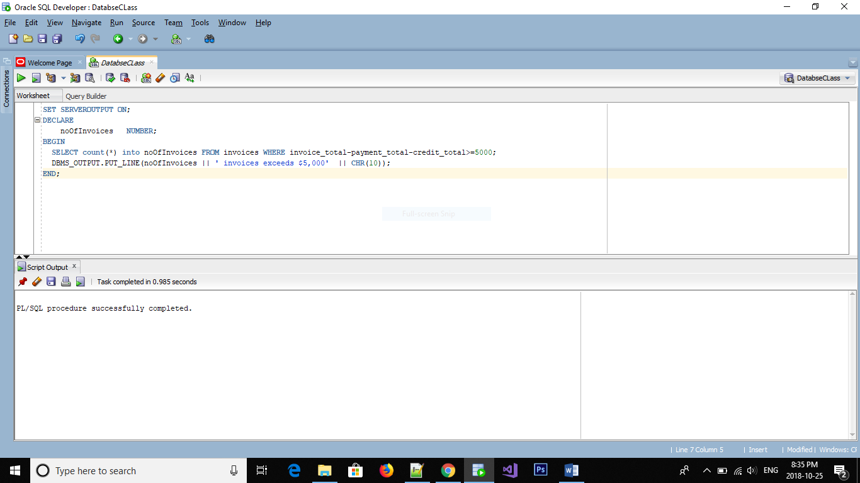

2.

DECLARE

noOfInvoices NUMBER;

totalDue NUMBER;

BEGIN

SELECT count(*) into noOfInvoices FROM invoices WHERE invoice_total-payment_total-credit_total>0;

SELECT sum(invoice_total-payment_total-credit_total) into totalDue FROM invoices WHERE invoice_total-payment_total-credit_total>0;

IF (totalDue>50000) THEN

DBMS_OUTPUT.PUT_LINE(CHR(10) || 'Number of unpaid invoices is' || noOfInvoices || CHR(10) || 'Total Balance due is ' || totalDue || CHR(10));

ELSE

DBMS_OUTPUT.PUT_LINE(CHR(10) || 'Total balance due is less than $50,000'|| CHR(10));

END IF;

END;

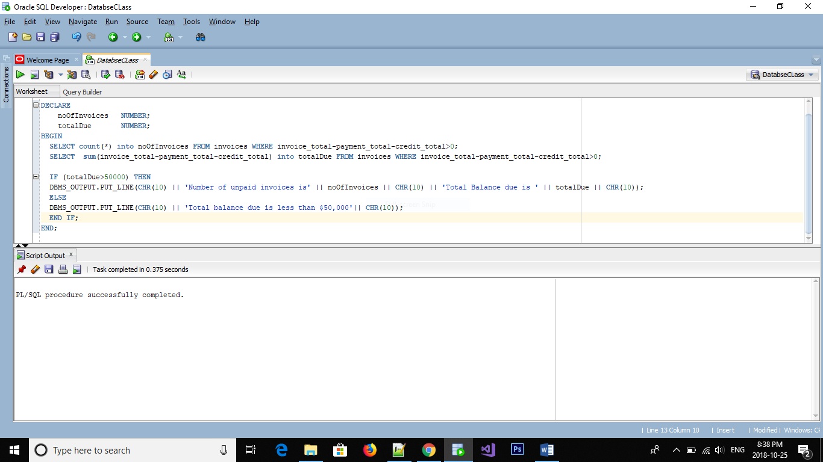

3.

DECLARE

CURSOR cursor_name IS

SELECT vendor_name, invoice_number, invoice_total-payment_total-credit_total balance_due

FROM invoices INNER JOIN vendors ON invoices.vendor_id=vendors.vendor_id

WHERE invoice_total-payment_total-credit_total>5000

ORDER BY invoice_total-payment_total-credit_total DESC;

BEGIN

FOR cursor_r IN cursor_name

LOOP

DBMS_OUTPUT.PUT_LINE(cursor_r.balance_due || CHR(9) || cursor_r.invoice_number || CHR(9) || cursor_r.vendor_name ||CHR(10));

END LOOP;

END;

